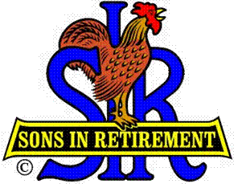

Las Trampas Branch 116

Luncheon Meeting Agenda

June 18, 2018

11:30 AM
- Call to Order – Big Sir.
- Welcome: Action Packed and Full Meeting Lets all pay attention and be Courteous
- Pledge of Allegiance:. Big SIR
- Invocation: Art Donaldson
- Story Teller: Conrad “Connie” Robertson
- Introduce Head Table
- Little Sir: Jerry Hicks
- Guest Speaker – Captain Eric Christensen, Captain of Oakley Police Department
- New Member: Ed Thomas, Tom O’Brien, Andy Myhr, Sponsor Jerry Hicks
- Introduce Guests & Visitors
- Guests: Mike Yale sponsor Tom Eller, Dave Hyland sponsor Dick Breitwieser, Bob Lewis sponsor Chuck Vanoncini
2018 New Members please rise and introduce yourselves.
- Visitors:

- Big Sir Comment
- OPEN SEATING AND TABLE ASSIGNMENTS Presentation

11:45 PM – Lunch
- Raffle Drawing
- Sunshine Report No Report Everyone is Fine 😊
- Committee Reports Golf will take some time

12:15 PM Let’s Eat

12:30 PM
Little Sir:
- Introduce Guest Speaker : Captain Eric Christensen, Oakley Police Department
- Ask May and June Birthday guys to stand / sing Happy Birthday (Paul King & Robbie)
- Sign off by Big Sir
- Sign God Bless America.

